**Assignment 2**

**UML & Use Case**

Thomas Coons: 000317961

Mohawk College

COMP-CO835-09: Object Oriented Systems

Dr. Stanley Ukah

September 24th, 2024

1. **Why is it important to obtain user stories in software projects?**Obtaining user stories in software development projects are important because user stories form the foundation of functional requirements the system needs to carry out. User stories are important because they are delivered to the programmer much earlier than use cases and are then implemented (Satzinger et al., 2016, p. 71).
2. **What is the purpose of UML use case diagrams, and why are use cases important?**  
     
   The purpose of a UML (Unified Modeling Language) graphically visualize the relationships between use cases their actors. Use cases are important as they define functional requirements. They allow us to understand what response is necessary when an action is requested by a user (Ukah, 2024, Slide 10).
3. **What is an event, and what are the three types of Events?**An event is “Something that occurs at a specific time and place, can be precisely identified, and must be remembered by the system” (Satzinger et al., 2016, p. 74).

**The Three Types of Events:**

* + 1. External Events
    2. Temporal Events
    3. State or Internal Events

1. **What is the «includes» relationship between two use cases?**

The includes relationship denotes that one use case might use the service of another use case (Satzinger et al., Year, p. 85). They are connected via inheritance.

1. 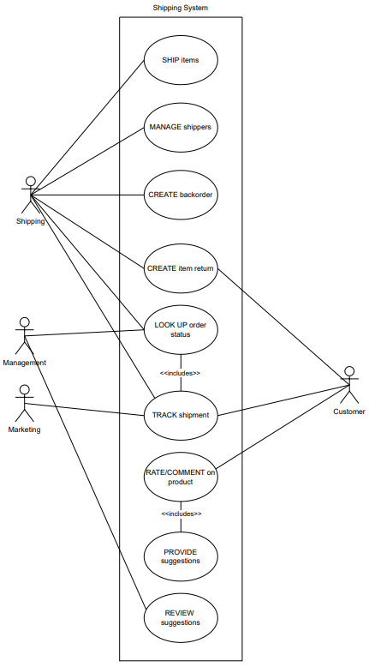

REFERENCES

Satzinger, J. W., Jackson, R. B., & Burd, S. D. (2016). *Systems Analysis and Design In*

*a Changing World* (7th ed).

Ukah, S. (2024). *COMP CO835 Object Oriented Systems*. [PowerPoint presentation]. Mohawk College